Jenkins connector

1. Go to Dynatrace->apps->hub

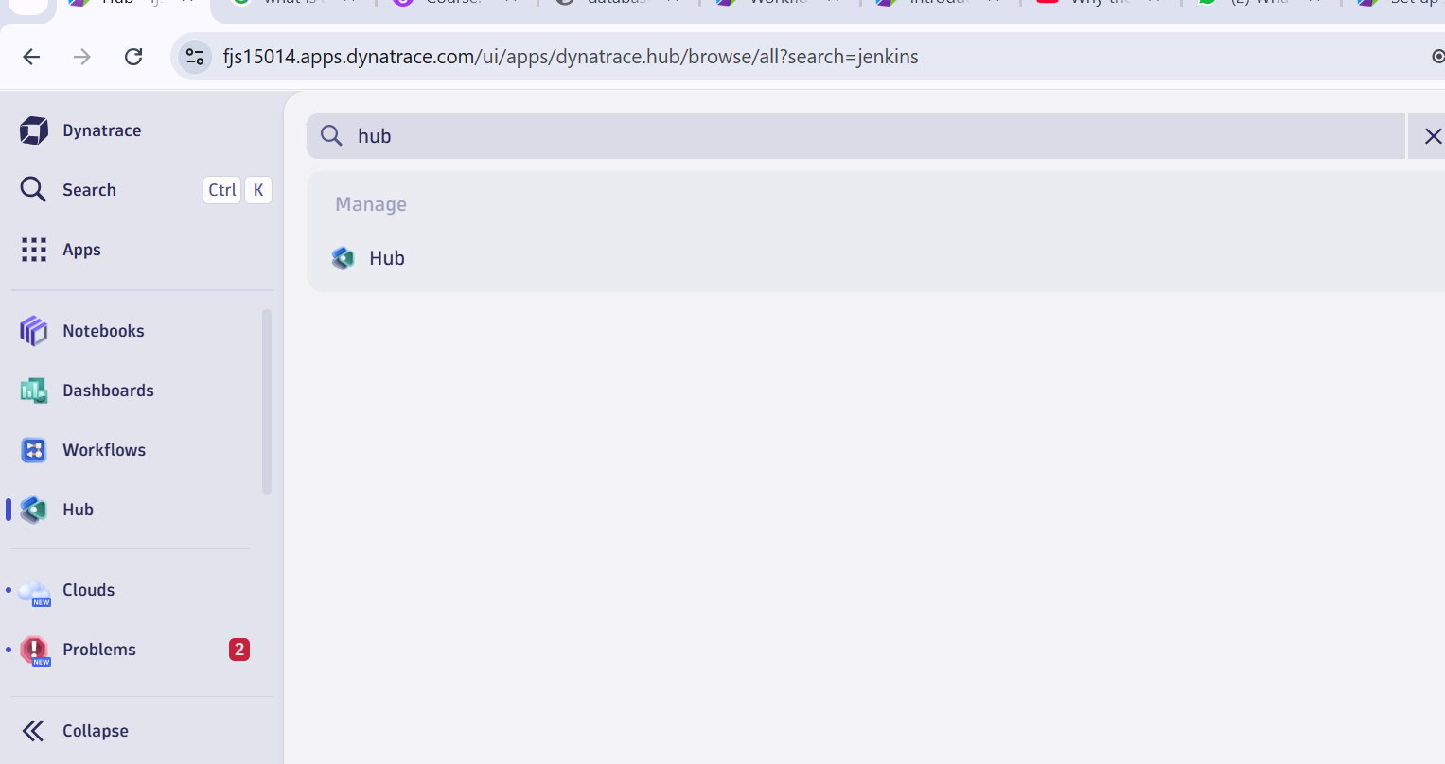

1. Search for Jenkins

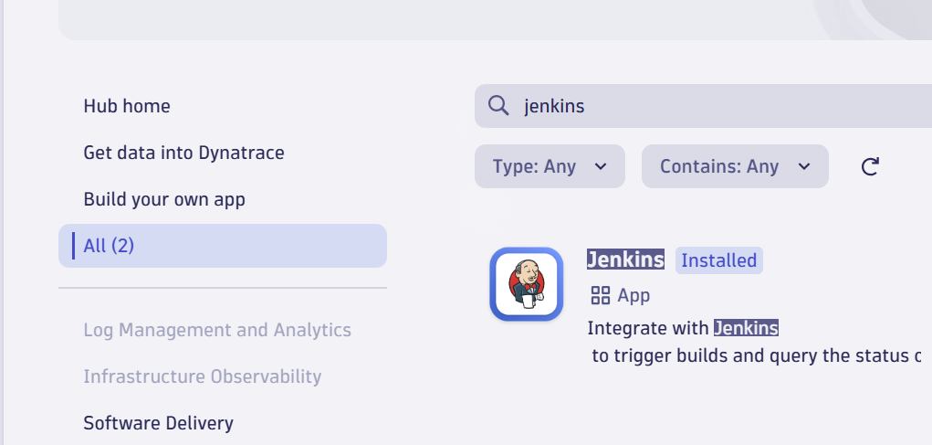

3)Click on Setup

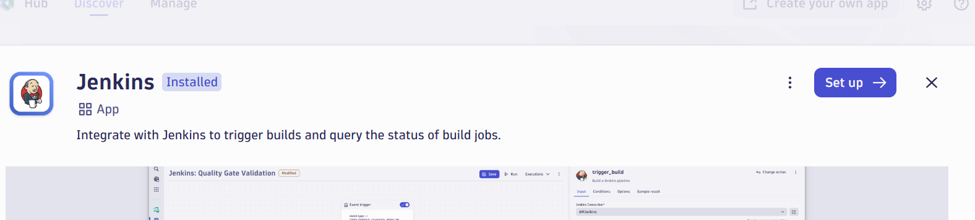

4)Click on general and check external requests

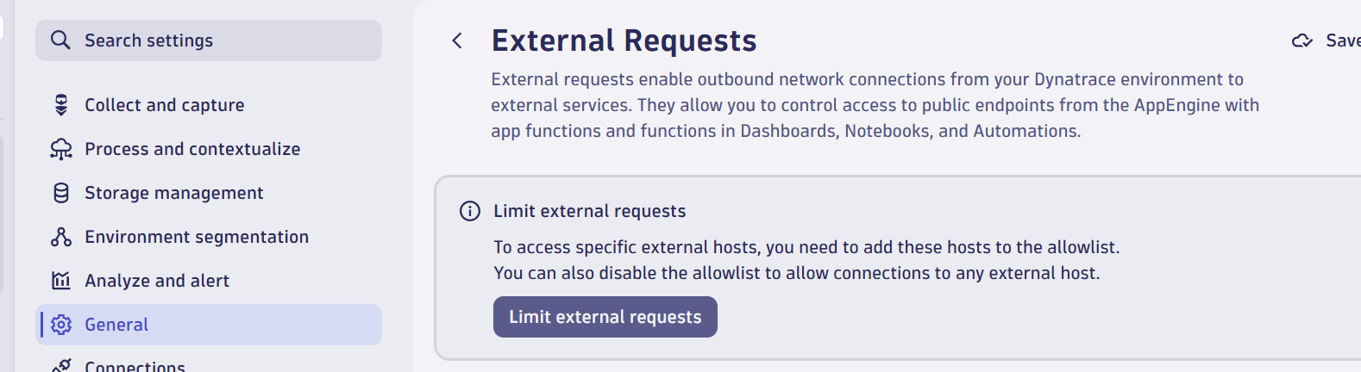

5) connection -> Jenkins

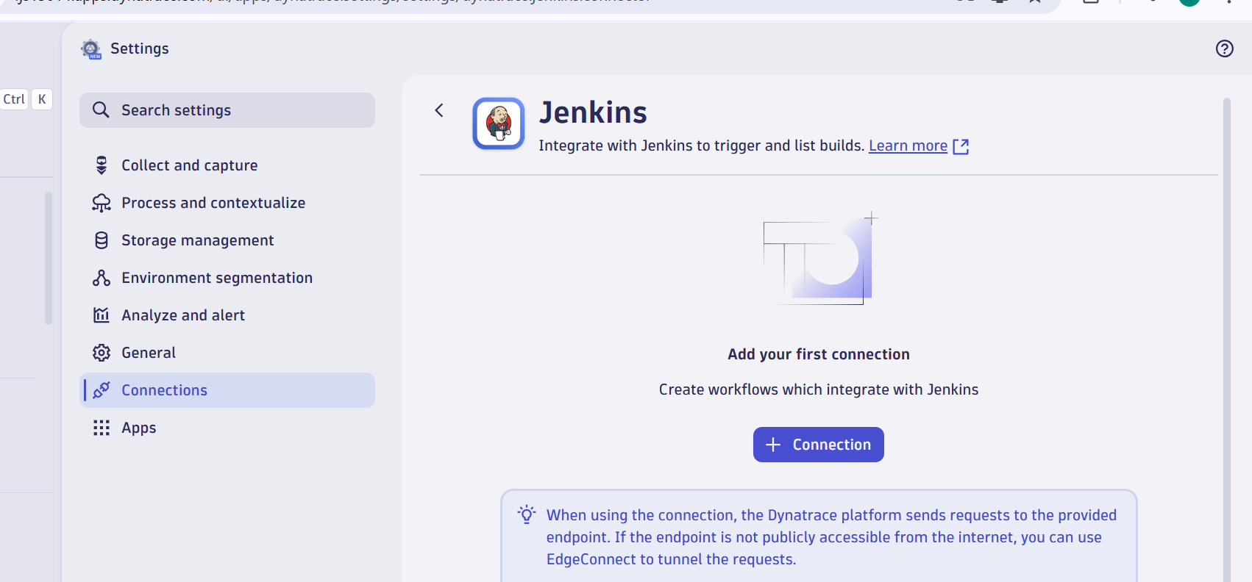

6)Provide details

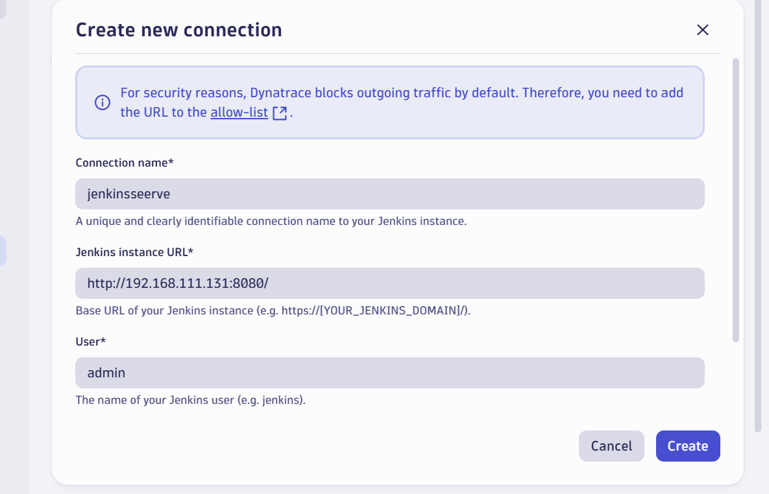

**Grant permissions to Workflows**

Some permissions are required by Workflows to run actions on your behalf. Other permissions are required by actions that come bundled with Jenkins Connector itself.

To fine-tune permissions granted to Workflows

1. Go to Workflows and select Settings > Authorization settings.
2. Select the following permissions besides the general Workflows permission.

* Permissions needed for Jenkins workflow actions:
  + app-settings:objects:read

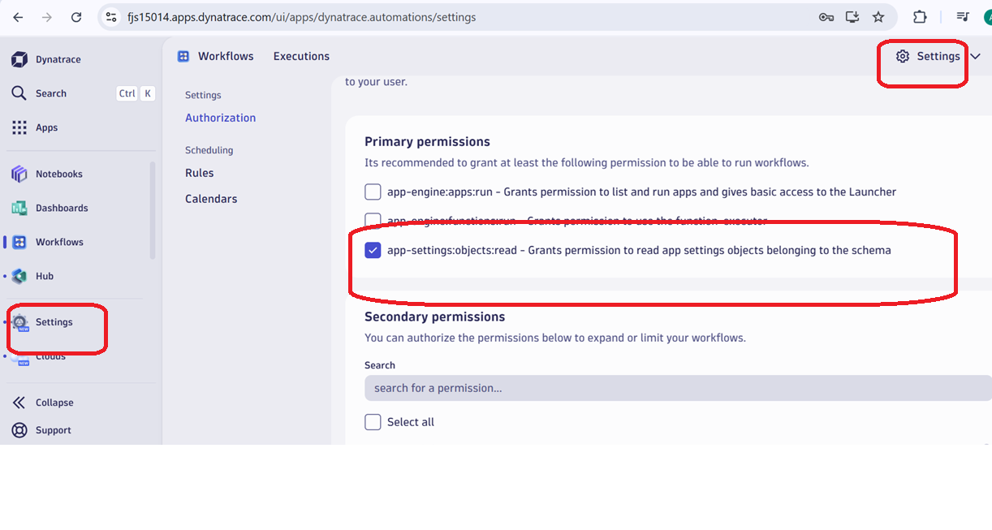

Setup ngrok

Go to workflow

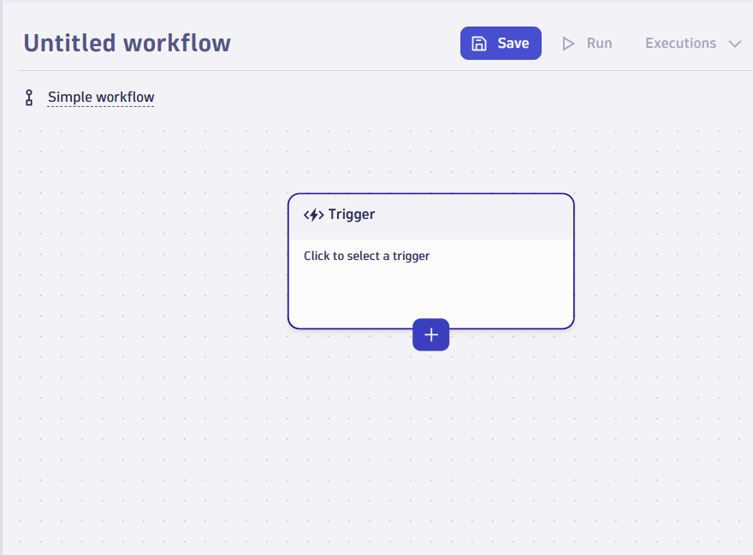

Create on +

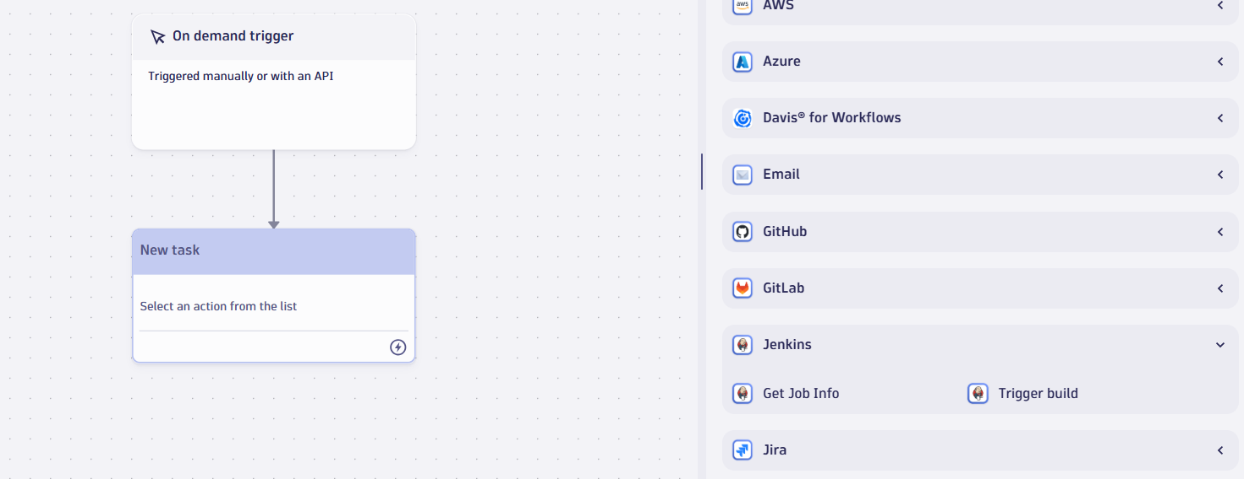

Get info on job

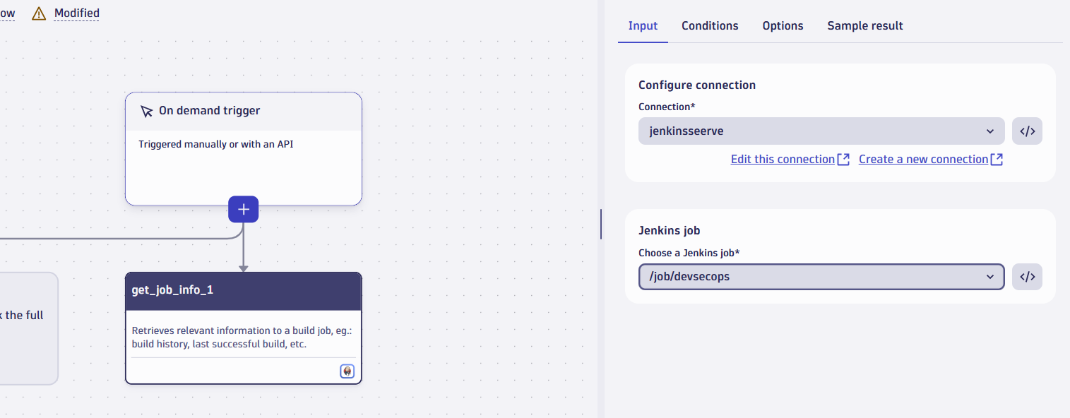

Click on Run

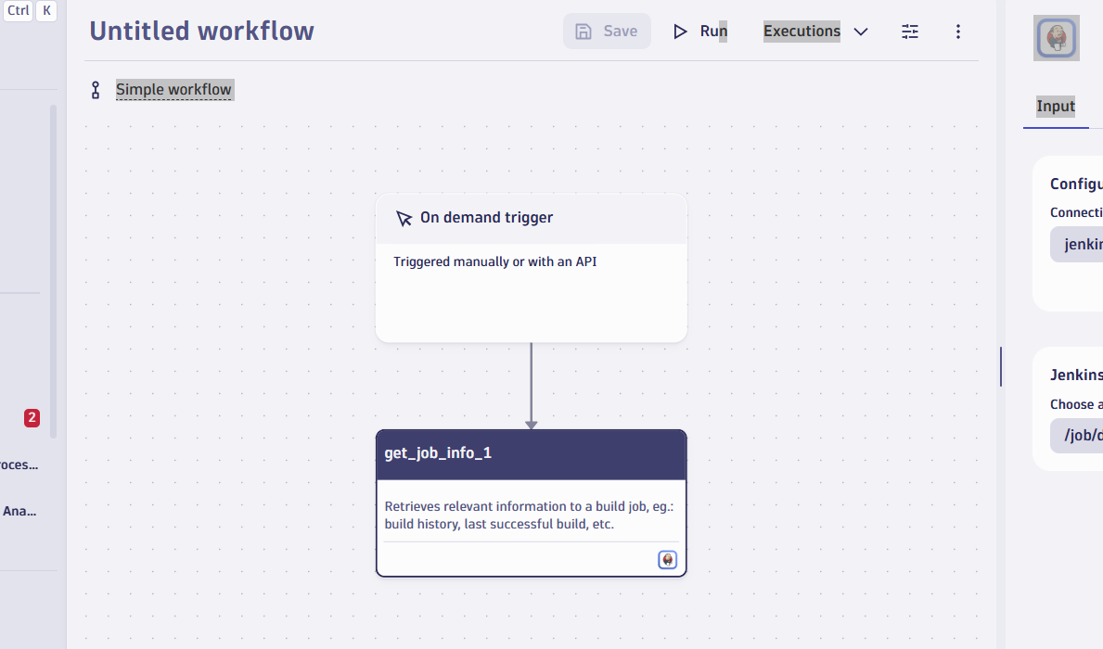

Get info

